|  |
| --- |
|  |
| 新概念 3 册 |
| **Lesson13 ‘It’s only me’** |

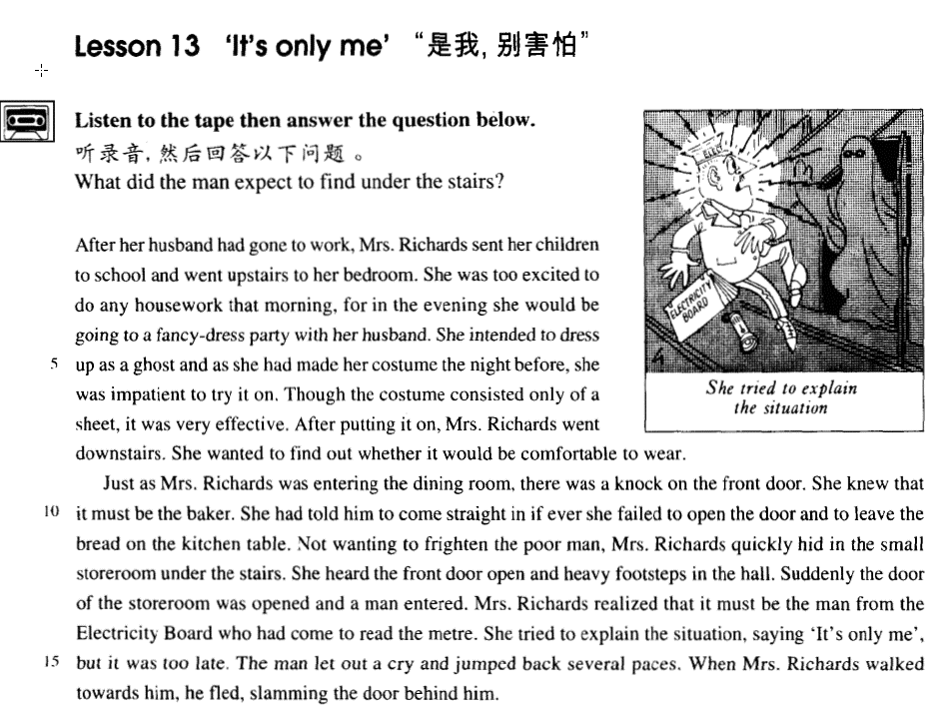

课文

After her husband had gone to work, Mrs. Richards sent her children to school and went upstairs to her bedroom.

理查兹夫人等丈夫上班走后，把孩子送去上学，然后来到楼上自己的卧室。

She was too excited to do any housework that morning, for in the evening she would be going to a fancy-dress party with her husband.

那天上午，她兴奋得什么家务活都不想做，因为晚上她要同丈夫一起参加一个化装舞会。

She intended to dress up as a ghost and as she had made her costume the night before, she was impatient to try it on.

她打算装扮成鬼的模样。头天晚上她已把化装服做好，这时她急于想试试。

Though the costume consisted only of a sheet, it was very effective.

尽管化装服仅由一个被单制成，却十分逼真。

After putting it on, Mrs. Richards went downstairs.

理查兹夫人穿上化装服后下了楼，

She wanted to find out whether it would be comfortable to wear.

想看穿起来是否舒服。

Just as Mrs. Richards was entering the dining-room, there was a knock on the front door.

理查兹夫人刚刚走进餐厅，前门就传来敲门声。

She knew that it must be the baker.

她知道来了一定面包师。

She had told him to come straight in if ever she failed to open the door and to leave the bread on the kitchen table.

她曾告诉过面包师，如果她不去开门，他可直接进门，把面包放在厨房的桌上。

Not wanting to frighten the poor man, Mrs. Richards quickly hid in the small storeroom under the stairs.

理查兹夫人不想吓唬这个可怜人，便赶紧躲到了楼梯下的小储藏室里。

She heard the front door open and heavy footsteps in the hall.

她听见前门被打开，走廊里响起重重的脚步声。

Suddenly the door of the storeroom was opened and a man entered.

突然贮藏门开了，一个男人走了进来。

Mrs. Richards realized that it must be the man from the Electricity Board who had come to read the metre.

理查兹夫人这才想到一定是供电局来人查电表了。

She tried to explain the situation, saying 'It's only me', but it was too late.

她说了声“是我，别怕！”然后想进行一番解释，但已来不及了。

The man let out a cry and jumped back several paces.

那人大叫了一声，惊退了几步。

When Mrs. Richards walked towards him, he fled, slamming the door behind him.

理查兹夫人朝他走去，只见他“砰”的一声关上门逃走了。

词汇讲解

* **costume** ['kɒstju:m] n. 化妆服
* The movie won Oscars for best **costumes** and best screenplay.

**historical costume** 古装

**traditional national costume** 传统民族服装

**overalls / coveralls* *n.*** 工作服

**uniform *n.*** 制服

school uniform

military uniform

sportswear ***n.*** 运动装；休闲服

underwear ***n.*** 内衣物

leisure wear 休闲装；休闲服；家居服

rags* ***n.*** 破布；抹布；乞丐服

shroud ***n.*** 寿衣；

* **consist** [kən'sɪst] v. 由……组成

表达“由…组成”短语：

**consist of ...**

**be composed of ...**

**be made up of ...**

**comprise**\* **...**

* The committee **consists of** 100 members.
* The committee **is composed of** 100 members.
* The committee **is made up of** 100 members.
* The committee **comprises 100** members.
* One hundred members **comprise** the committee.
* One hundred members **make up** the committee.
* One hundred members **compose** the committee.
* One hundred members **constitute** the committee.
* **sheet [ʃi:t]** n. 床单，被单
* a **sheet** of paper 一张纸（固定规格的）
* The snow came down in **sheets**（大片的）.

bedspread ***n.*** 床罩；床单

Mattress ***n.*** 床垫；褥子；空气垫

eiderdown ***n.*** 凫绒被；凫绒

blanket**\*** ***n.*** 毛毯，毯子；毯状物，覆盖层

pillow**\*** ***n.*** 枕头

bedclothes**\*** / bedding ***n.*** 床上用品

single bed 单人床

double bed 双人床

bunk**\*** (bed)

hammock**\*** ***n.*** 吊床；吊铺；吊带

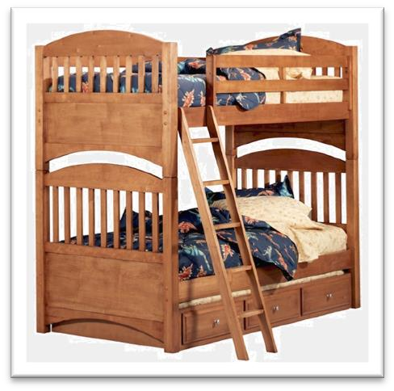

* **metre / meter** ['mi:tə(r)] **n. 仪表**

an electricity meter

a water meter

a gas meter

read the meter 查表

thermometer **\**n.*** 温度计；体温计

barometer**\*** ***n.*** [气象] 气压计；晴雨表；显示变化的事物

odometer**\*** / milometer **\**n.*** （汽车的）里程表，[车辆] 里程计

speedometer**\* *n.*** 速度计；里程计

* **pace [peɪs]** n. 一步，步伐

**pace / step** 步伐(同义词)

* take one pace / step forward 向前迈步
* quicken one’s pace / step 加快步伐

**pace / tempo\*** 节奏、速度

* the pace / tempo of life
* the fast pace / tempo of modern life

**keep pace with …** 跟上…的步伐

* It is important for a company to **keep pace with** changes in the market.

**stride** ***n.*** 大步；步幅；进展

**make strides in** ... 长足的进步

* Medical science has **made great strides** in tackling infertility**\***.

**leap *vi.*** 跳，跳跃 (用力往前跳)

* That’s one small step for a man, one giant leap for mankind. — Neil Armstrong

**by leaps and bounds**: very quickly

* **听力真题：**

1. He's growing very quickly.
2. He's the tallest of three boys.
3. He can jump high.
4. He has to leave today at there.

M: Your little nephew is growing **by leaps and bounds**.

W: Yes. He must be at least three feet tall already.

Q: What do the speakers say about the woman’s nephew?

Answer: (A) He's growing very quickly.

* **flee** [fli:] **v. 逃走，逃离** (强调被吓跑)

flee fled fled fleeing

* When Mrs. Richards walked towards him, he **fled**, slamming the door behind him.

**abscond**\* ***vi.*** 逃匿，潜逃；避债 (偷偷摸摸的跑)

* abscond with money

**elope**\* ***vi.*** 私奔；潜逃

**elope with sb.**

**escape**

* escape from the prison
* **slam** [slæm] **v. 砰地关上**
* The door **slammed** (shut).
* Don’t **slam** the door.

**bang** 发出砰的一声；砰砰作响

* The door **banged** (shut).
* Don’t **bang** the door.
* The door shut with a **slam/bang.**
* **听力真题：**

1. The dog shut the door.
2. The shout was heard through the door.
3. The door of the bank was locked.
4. The door closed loudly.

The door banged shut.

Answer: (D) The door closed loudly.

课文讲解

# After her husband had gone to work, Mrs. Richards sent her children to school and went upstairs to her bedroom.

**send**（打发） **sb. to + n.** （去某个地方，to是介词）

**send**（打发） **sb. to do** （不定式）

* I sent the boy to school / bed.
* I sent the boy to buy some beer.

**dispatch* *vt.*** 派遣；分派

**dispatch**（派遣） **sb. to + n.** （去某个地方，to是介词）

**dispatch**（派遣） **sb. to do** （不定式）

* An ambulance**\*** was immediately dispatched to the area.
* The government dispatched 150 police to restore order.

**transfer sb. to + n.** 把某人派到某地（用于工作场合）

* She was transferred from marketing to sales.

**transport sb. to + n.** 把某人流放某地（强制）

* He was transported to Siberia **for life**（余生）.

**“房间”词汇：**

hall ***n.*** 过道，门厅，走廊；会堂；食堂；学生宿舍；大厅，前厅；娱乐中心，会所

living room (客厅)/ sitting room (客厅)/ drawing room（豪华的客厅）

dining room ***n.*** 饭厅；餐厅

kitchen ***n.*** 厨房；炊具；炊事人员

bathroom ***n.*** 浴室；厕所；盥洗室

guestroom ***n.*** （家庭中的）来客住房

study ***n.*** 学习，研究；课题；**书房**；学问

bedroom ***n.*** 卧室

master bedroom ***un.*** 主卧室

storeroom ***n.*** 库房；储藏室

attic / loft* ***n.*** 阁楼；顶楼；

basement ***n.*** 地下室；地窖 (可住人)

cellar* ***n.*** 地窖；酒窖；地下室

balcony ***n.*** 阳台；包厢；戏院楼厅

* Just as Mrs. Richards was entering the dining room, there was a knock on the front door.
* She had told him to come straight in if ever she failed to open the door and to leave the bread on the kitchen table.
* Not wanting to frighten the poor man, Mrs. Richards quickly hid in the small storeroom under the stairs.
* I left the bag in the hall and Robert and I went into the living room where we talked for a couple of hours.
* George showed me to the guestroom which, he said, was rarely used.
* My cousin, Harry, keeps a large curiously shaped bottle on permanent display in his study.
* Looking into the drawing room, she saw a scene of confusion over by her writing desk.
* The inspector began to look for fingerprints, while the constable checked that the front door locks had not been forced, thereby proving that the burglars* had either used skeleton keys or entered over the balcony.
* Her first impulse was to go round all the rooms looking for the thieves, but then she decided that at her age it might be more prudent to have someone with her, so she went to fetch the porter from his basement.
* They had mysteriously found their way there from the wine cellar!
* They leave unwanted objects in drawers, cupboards and attics for years, in the belief that they may one day need just those very things.

# She was too excited to do any housework that morning, for in the evening she would be going to a fancy-dress party with her husband.

housework ***n.*** 家务事

homework ***n.*** 家庭作业，课外作业

household chore(可数)* 家务活

* I spent all morning doing (the) housework / household chores.

**do / wash the dishes** 洗碗

**do the washing-up** 洗碗

* **托福听力真题：**

1. He has to wash a thousand dishes.
2. He has more dishes than his brother.
3. His brother takes too much time washing the dishes.
4. He has asked his brother to wash the dishes many times.

W: Have you asked your brother to **do the dishes**?

M: Thousands of times.

Q: What does the man mean?

Answer: (D) He has asked his brother to wash the dishes many times.

**do the laundry* / washing** 洗衣服

语法：将来进行时

* He will soon be working in an office.
* He will be earning only half as much as he used to, …

**fancy-dress costume** 化妆服

**fancy-dress party** = **masquerade**\* 化妆晚会

# She intended to dress up as a ghost and as she had made her costume the night before, she was impatient to try it on.

**intend to do** 打算做某事

**tend to do** 往往

* We intend to go to Australia next year.

**mean to do** 打算做某事

* Sorry, I didn’t mean to scare you.
* He always meant to go back one day but not to stay.

**be going to do** 打算做某事

* I’m going to have my hair cut this weekend.
* Both planes were going to take off on July 25th, but Latham failed to get up early enough.

**have every intention of doing …** 打算做某事（更正式）

* I had every intention of phoning her this morning, but I just didn't get a chance.

**否定**

**not intend to do**

**not mean to do**

**have no intention of doing …**

* I had no intention of buying one, but I could not conceal the fact that I was impressed by the size of the diamonds.

**dress up as …** 装扮成，打扮成…

**dress sb. up as …** 把某人打扮成…

* We dressed him up as a gorilla.
* …, he immediately telephoned the police and informed them that two students dressed up as workmen were tearing up the road with a pneumatic drill.
* **造句**：他打扮成一个鬼去参加这个化妆晚会。

He went to the fancy-dress party dressed up as a ghost.

**disguise sb. as …** 把某人打扮成…

* He disguised himself as a dustman.
* **课后习题讲解：（page 29, Lesson 4）**

2. What did Alfred Bloggs do for over two years?

(a) He told his wife he worked for the Corporation, when in fact he did not.

(b) He disguised himself as a dustman.

(c) He led a double life. 正确

(d) That office workers usually earn less than manual workers.

**disguised as ...** (非谓语)

* Alfred the Great acted as his own spy, visiting Danish camps disguised as a minstrel.

**dress up** 穿着过于正式

* You don’t need to dress up for a casual* party.

**overdressed** ***adj.*** 过分打扮的；穿着过于讲究的

* I think we are overdressed.

**dress down** 穿着随意不正式

* In many offices, people dress down on Fridays.

**underdressed *vi.*** 穿着过分朴素、随意的衣服

* Everyone else was in smart suit and I felt a bit underdressed.

表达“前一天晚上”

the night before(副词)

the earlier / previous / preceding night

表达“后一天晚上”

the night after

the next / following / succeeding night

表达“急切的去做某事”

**be impatient to do …**

**be eager / anxious / itching* / desperate / dying to do**

**… can’t wait to do …**

# Though the costume consisted only of a sheet, it was very effective.

同义表达替换：

Though the costume **was composed** only of a sheet, …

# After putting it on, Mrs. Richards went downstairs.

# She wanted to find out whether it would be comfortable to wear.

**语法**：形容词后加动词不定式作补语，用主动表被动的含义

* He is *easy* to fool.
* She is extremely *difficult* to please.
* The machine is *awkward* to handle.
* The man is *hard* to work with.

# Just as Mrs. Richards was entering the dining-room, there was a knock on the front door.

表达“就在那个时刻”同义替换：

**At the very moment (when)** Mrs. Richards was entering the dining room, …

先行词如果时表时间的名词，when可省略

* **课后习题讲解：**

9. ____A____ Mrs. Richards was entering the dining room ... (1.9)

(a) At the very moment

(b) So long as

(c) Only when

(d) During the time

**语法：**无零主语

there was **a knock** on the front door. （无零主语）

…, somebody knocked at the front door. （somebody多余）

* There are more and more people who are interested in English in China. （语法正确，表达不地道，对英语感兴趣肯定是人，可以省略）
* There is increasing interest（无灵主语） in English in China. （更好的表达）
* People generally agree that women should enjoy full equality with men.
* There is general agreement （无灵主语）that women should enjoy full equality with men. （更好的表达）
* The sea bed was scoured with powerful nets and there was tremendous excitement on board when a chest was raised from the bottom.
* While the quality of legal journalism varies greatly, there is an undue reliance amongst many journalists on interpretations supplied to them by lawyers.

# She knew that it must be the baker.

推断是谁的时候用 **it**

Who is it?

Who is there?

# She had told him *to come straight in* if ever she failed to open the door and *to leave the bread on the kitchen tabl*e.

**straight**: directly; immediately; without delay 直接，不耽搁的（跟在中心动词后面）

* I got home and went straight to bed.
* Time is short so I’ll get straight to the point.
* **听力真题：**

1. Pick up the man at 1:00.
2. Meet her friends at the restaurant.
3. Make lunch for the man.
4. Do her errands after lunch.

M: We thought we'd all go out for lunch today. Can you be ready to leave at one o'clock?

W: I have to pick up my car and do a couple of other errands*. So I'll just come straight to the restaurant.

Q: What will the woman do?

Answer: (B) Meet her friends at the restaurant.

if ever she failed to open the door____

Maybe she was asleep.

Maybe she was on the phone.

Maybe she was listening to music.

Maybe she was in the bathroom.

* **课后习题讲解：**

10. - if she ever____D____ the door and to leave the bread ... (11.10-11)

(a) missed opening

(b) forgot to open

(c) did not succeed in opening

(d) happened not to open

**leave** 留下某事，人走掉

* Please leave a message.
* Please leave your address.
* Did anybody leave a jacket behind last night?

# Not wanting to frighten the poor man, Mrs. Richards quickly hid in the small storeroom under the stairs.

Because she didn’t want to frighten the poor man, …

* Because he didn’t want to be recognized, the suspect dressed up as a priest.
* Not wanting to be recognized, the suspect dressed up as a priest. （非谓语）

# She heard the front door open and heavy footsteps in the hall.

# Suddenly the door of the storeroom was opened and a man entered.

# Mrs. Richards realized that it must be the man from the Electricity Board *who had come to read the metre*.

表达“某人想到某事”

**sth. occur to sb.**

**sth. strike sb.**

**sth. dawn* on sb.**

* It suddenly occurred to one of the workers to open up the box.
* It suddenly struck me how we could improve the situation.
* It suddenly dawned on me that this express was not roaring down the line at ninety miles an hour, but barely chugging along at thirty.

课文表达替换：

Mrs. Richards realized that it must be

* It suddenly occurred to Mrs. Richards that it must be …
* It suddenly struck Mrs. Richards that it must be …
* It suddenly dawned on Mrs. Richards that it must be …

介词：from强调从哪来的

the man from the Electricity Board

* experts from the zoo

介词：for强调在哪工作

* a spokeswoman for the Bank

介词：of 既不强调从哪来的，也不强调在哪工作

* editors of newspapers and magazines the Water Board

**board** n. 委员会；理事会；董事会；(政府的) 部，局，会

* the Gas Board
* the board of directors
* He is on the board / a board member.

**read the meter** 查表

**take a meter-reading** 查表

**read music** 识谱

read one’s mind 看透某人的心思

read one’s palm* 看手相

# She tried to explain the situation, saying 'It's only me', but it was too late.

She tried to explain the situation and said ‘it’s only me’. （这种并列写法没有突出表达）

汉语：parataxis—平行语，连动句，没有轻重之别。

英语：hypotaxis—层次语，突出中心动词，次要动词状语化。

She tried to explain the situation and said ‘it’s only me’. （突出explain）

Trying to explain the situation, she said ‘it’s only me’. （突出said）

* **课后习题讲解：**

7.Trying to explain the situation, she ___b___‘It’s only me’. (1.14)

(a) was saying (b) said (c) had said (d) has been saying

He looked at his watch and saw that it was one o'clock, but the bell struck thirteen times and then it stopped. （没有突出）

Looking at his watch, he saw that it was one o'clock, but the bell struck thirteen times before it stopped.

**语法**：独立主格

**(with) + n. + 非谓语 (doing / done / to do, 其中 being 常省略)**

* He stopped running and sweat streamed down his face. （没有突出）

He stopped running (with) sweat* streaming down his face. （突出stopped）

He / With him stopping running sweat streamed down his face. （突出sweat）

# The man let out a cry and jumped back several paces.

**let out** 专门表示人发出叫喊声（专业表达）

let out a cry（大声叫喊） / scream （尖叫）

utter* a cry / scream 发出叫喊

give a cry / scream 发出叫喊

# When Mrs. Richards walked towards him, he fled, slamming the door behind him.